Campus courts a degree too far
Bettina Arndt
The Australian
November 7, 2019
https://www.theaustralian.com.au/commentary/campus-courts-a-degree-too-far/news-story/82e23fc5ff7756cabb838db832d401f7

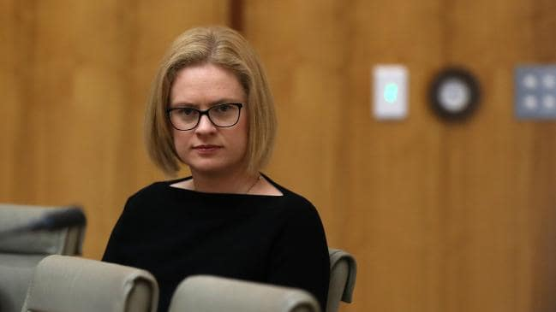
Senator Amanda Stoker waved its one-sided report in front of squirming TEQSA representatives during a Senate estimates committee. Picture Kym Smith

Do universities have the jurisdiction to hear allegations of criminal behaviour?

This is being considered by Queensland’s Supreme Court Justice Ann Lyons in a pivotal case that puts on notice university regulations being used across Australia to investigate and adjudicate sexual assault.

The case involves a University of Queensland medical student accused of sexually assaulting another student, digitally penetrating her without her consent. Last month, the male student was issued an “allegation notice” from UQ’s disciplinary board, inviting him to attend a board hearing.

At the October 16 Supreme Court hearing (Uber v University of Queensland) the student’s lawyer, Wendy Mulcahy, argued that the university “does not have the jurisdiction to hear and make findings about such allegations” and sought a permanent injunction to prevent the disciplinary hearing.

Here is a student who was due to sit his final exams for a postgraduate doctor of medicine degree next month, who is now facing investigation by a university committee that has the right to expel him. Newspapers have published explicit details of his unnamed accuser’s version of events. His name is published but his story is unheard.

Universities have taken it on themselves to usurp the criminal law system, introducing new regulations for adjudicating sexual assault, using a “balance of probabilities” standard of proof, and making no provision for protecting the legal rights of the accused.

This followed an orchestrated campaign by feminist activists who successfully persuaded the Australian Human Rights Commission to spend $1m on a survey seeking evidence of a “rape crisis” on university campuses. This proved a fizzer for the activists, showing only tiny numbers experiencing sexual assault (an average of 0.8 per cent across each of the two years studied), even using a broad definition including touching by a stranger on public transport to the campus.

The main finding was low-grade sexual harassment (mainly unwanted staring), which the universities immediately promoted as alarming levels of “sexual violence”.

Universities claim their new regulations are in response to the Tertiary Education Quality and Standards Agency’s 2018 “guidance notes” advising universities to provide evidence about how they respond to sexual assault.

The opening paragraph of TEQSA’s 2019 report on this issue mentions approvingly an alarmist feminist movie called The Hunting Ground, denounced by 19 Harvard law professors for promoting “unfair and misleading propaganda”.

Both the TEQSA document and resulting university regulations display the same bias, focusing entirely on providing proper care for alleged sexual assault victims with absolutely no mention of protecting legal rights of the accused — who are usually, of course, young men.

This point was made to great effect last week in a Senate estimates committee by Amanda Stoker as she waved its one-sided report in front of squirming TEQSA representatives.

The accused, she explained, had no access to evidence against them, there was no effort to ensure the reliability of that evidence, no power to call evidence in their own defence, no legal representation, no presumption of innocence, no right of appeal. Instead, a secretive, unsupervised committee would determine guilt on the balance of probabilities with power to impose serious penalties including expulsion from the university.

As Stoker has pointed out, this means students thus punished have wasted money and time invested in their degrees and are likely to be excluded from chosen professions — all penalties not found in the criminal justice code.

The sheepish TEQSA representative admitted the processes Stoker described appeared “deeply flawed”.

One university administrator recently acknowledged in correspondence with a student representative that the university could have proceeded with a misconduct hearing even if the accused had been found not guilty in criminal court. The reason? The university had a lower level of proof, he said.

That’s the point of this exercise, as activists make clear: to use victim-centred justice to ensure more rape convictions.

That was widely acknowledged as the goal in 2011 when former US president Barack Obama required all publicly funded universities to establish tribunals to adjudicate rape on campus. The resulting kangaroo courts led to more than 200 successful lawsuits against universities for failing to protect due process rights of the accused — rights the US administration of Donald Trump seeks to restore.

Given that recent history, it is extraordinary our higher education sector has allowed itself to be led down the same damaging path.

Universities Australia has just commissioned a new survey, seeking to cook up more impressive rape statistics.

Before the election in May, key feminist lobby groups almost succeeded in establishing a government taskforce aimed at further bullying universities to take action against sexual assault. “We were so close,” moaned Darren Brown, Simon Birmingham’s higher education officer, before the new minister shelved the proposal.

It’s a relief to finally see a few shots across the bow of this mighty feminist enterprise, with Stoker exposing TEQSA’s complicity and the pending UQ legal case. There’s more to come.

Bettina Arndt is a contributor to Jordan Peterson’s Thinkspot website.

